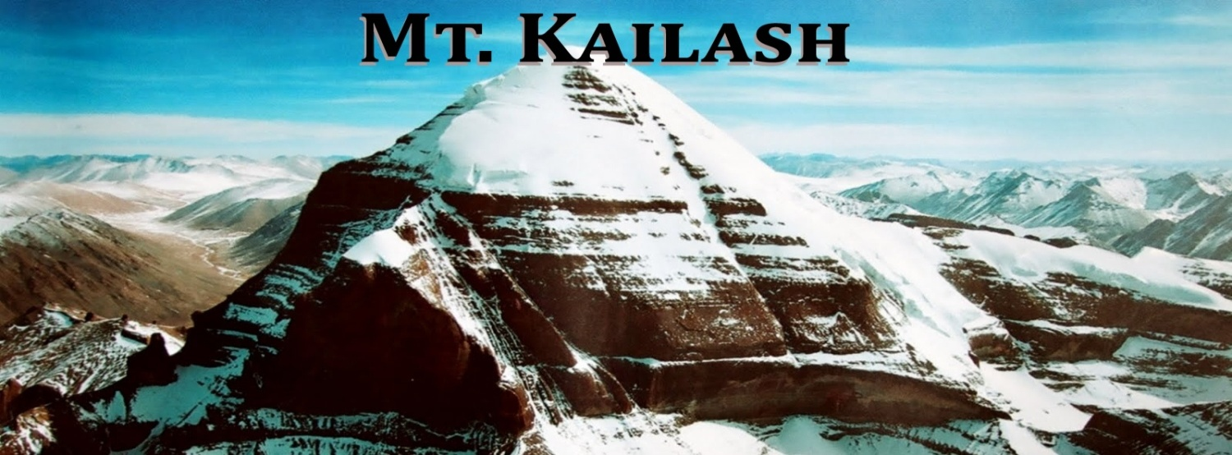
Itinerary: Kailash Mansarovar Yatra by Luxury Coach from Kerung - 14 Days

Package Cost per person @ INR 1, 35,449.00 +5% GST extra for Indian Passport Holders.

Day 01: Kathmandu (1300 mts.) Arrival, our representative will meet at the airport and escort to the Hotel, Program briefing at the evening, dinner, overnight stay in Kathmandu.

Day 02: Katmandu to Syabrubeshi (3700 mts. - 140kms.) - This is the first day of the Yatra. Very early with pack breakfast depart from Katmandu to near China border by reserved tourist coach. O/N stay at the hotel.

Day 03: Drive from Syabrubeshi to Kerung - Our agent will complete custom formalities and check into Tibet - an autonomous part of China. After lunch drive to a small Tibetan town called Kerung, Overnight stay at Guest House.

Day 04: Kerung Full day acclimatization - Full day free for excursion of Kerung city.

Day 05: Kerung to Saga /Dongba(4500mts. - 375kms) - After breakfast drive from Kerung to Saga/Dongba .Overnight stay at Guesthouse.

Day 06: Saga/Dongba (4500mts. - 335kms) to Mansarovar - After breakfast drive from Dongba to Mansarovar 07:00 hours. Conducting Mansarovar Parikrama by vehicle. This is the first day stay at the bank of the Manasarovar Lake. This is the first day stay at the bank of the Manasarovar Lake, Overnight stay at Guesthouse.

Day 07: Mansarovar to Darchen (4600mts. - 110kms.) - We will choose the special point to take dip in Manasarovar Lake and conducting Pooja, hawan and spiritual activities according to your tradition. Drive around 2.30 hrs to Darchen and overnight stay at Guesthouse. Astapad excursion can be done at extra cost.
Day 08: Darchen to Diraphuk (4890mts. - 12kms.) - This is the first day of Kailash Parikrama. We should start our journey after breakfast as early as possible. This day we drive up to yumdwari and start walking continuously for about 6 to 7 hours. Horse can be hired at extra cost those who cannot walk. Yak will carry the kitchen utensils and equipment. Overnight stay at mud house or tent on the basis of availability.

Day 09: Diraphuk to Zhulthulphuk (4790mts. - 22kms.) - This day is bit complex journey and we have to pass Dolma-La Pass, which is 5400 meter in height, the weather is unpredictable in Doma-la Pass and at any time snowstorm can fall. So we try to start our journey as early as possible. In route we can have Darshan of Gaurikund but it is very difficult to go and touch. Overnight stay at mud house or tent on the basis of availability.

Day 10: Zhulthulphuk to Saga/Dongba- Later our tour starts back for Kathmandu following the same route and same system applies for all subjects of our accommodation and meal Overnight stay at guesthouse.

Day 11: Saga/Dongba to Kerung - Drive back to Kerung, which is the last stay in Tibet part.

Day 12: Kerung to Katmandu - After custom formalities we will be picked up by Nepal side and continue drive to Kathmandu and check in at Hotel.

Day 13: Katmandu - After breakfast start to Katmandu sightseeing including Pashupatinath and Budha Nikanth Darshan, back to hotel and rest. overnight stay in Katmandu.

Day 14: Departure-
Morning check out hotel, transfer to airport, catch flight for next Destination
Options for early departure or you use your extra day for Himalayan mountain flight, Manakamana road trip, or Muktinath tour.

ESTIMATE FOR ADDITIONAL ACTIVITIES

- Horse for personal ride on kora days is approx USD 400.00
- Extra day in Kathmandu USD 45.00 for with 2 meals and accommodations.
- USD 55.00 for Manakamana day trip including both way cable car tickets and transportation.
- Muktinath and Manakamana day trip USD 555.00 per person including two nights in Pokhara, one night Jomsom round trip flight with meal, transport.

COST INCLUDES:

- Arrival & departure transportation
- Sightseeing tour of Pashupatinath and Budhanilkantha.
- 3 nights 3 star hotel at Kathmandu on twin sharing basis with all meals
- Transfer to Kerung by tourist bus
- Tibet side: accommodation in decent hotel/Guest House
- Pure vegetarian meals prepare by our escort.
- A/C coach & support trucks
- English speaking Tibetan guide
- Nepali tour leader
- Gamow bag, oxygen, basic first-aid kit.
- Kailash permit & normal Tibet/China visa fee.
- Kerung land tax.

COST EXCLUDES:

- Airfares from Home - Kathmandu - Home
- All beverages, Photography charges and Telephone calls
- Travel Insurance of clients
- Emergency evacuation expenses.
- Riding Yak/Horse for Kailash Parikrama (direct payable to Yak/horse herder)
- Extra cost in the event of landslide for hiring additional transportation
- Expenses of personal urgent visa fee etc & Services other than specified

MODE OF PAYMENTS
15 days prior to tour departure date, 100% of the total cost should reach Shiv Bhole India Travels Pvt. Ltd. Account.

TOUR CANCELLATION POLICY

- All notice of cancellation must be sent to our office in written. Verbal cancellations will not be entertained.
- Booking Amount @ INR 15,000.00 per Person Non Refundable
- 15 days before trip departure 50% of total trip cost.
- 10 days before trip departure 90% of total trip cost.
- 07 days and less departure 100% of total trip cost.

IMPORTANT PRE-DEPARTURE INFORMATION:

Clothing:
Casual wears and comfortable walking shoes are recommended to travel to Tibet. Be sure to bring warm clothing as nights and early mornings can be quite chilly to downright cold. Indian woman Pilgrims strictly advisable no Sari. Bring all the film, medicine, cosmetics, personal toilet items etc. that you will need from home as these are difficult if not impossible to obtain on the way. A small first aid kit is also a good idea. Also quite useful to have a route map, to know where you are going and have been each day.

What to take:
Winter wear: Gore-Tex material though expensive is highly recommended. Down jacket, raincoat or windbreakers, thermal under wears, Jackets, warm trousers & woolen shirts (cotton will also do), warm sweaters, woolen gloves, sun hat, sun glass, comfortable shoes, light leather boots in case of snow, woolen balaclava ('monkey cap') & scarf/dust mask to protect your eyes & nose from dust.

Bring with you:
Snacks along the way. Chocolates, dry fruit, toffees, glucose; 'namkeen' etc. Strong water bottle & water purifying tablets. Personal medical kit and Diamox tablet (for high altitude). Sun glasses (to protect your eyes from UV, which is especially strong in high altitudes). Sun block or sun screen lotion, wet tissues (Fresh-ones are excellent to wipe off the dust), clothes-line/clips, needle & thread, deo-spray (handy for smelly boots/feet and for a round of spray in the toilet tent!), toilet paper, torch & spare batteries, daypack (small shoulder bag), Camera & films, Binocular.

Health:
This is one of the toughest high altitude road journeys on earth. You Must be physically fit - no two ways about that. Generally patients with asthma & heart problems have a problem acclimatizing to high altitudes. In your interests it is essential you should be examined by your doctor to know about your health condition and your ability to cope up with the rigors of high altitude travel for days in 'no road' conditions, extreme cold, dust, trekking to an altitude of 19500ft during the Parikrama, etc.

Altitude Sickness:
As you are traveling over high terrain, you are likely to experience symptoms and discomfort of altitude sickness (headache, loss of appetite, nausea, exhaustion, sleeplessness, breathlessness etc.) until your body adjusts to the elevation. This can take a couple of days or more depending on an individual. For this reason alone, we have made it mandatory to stay 2 nights at Nylam (12000ft) before moving on to the higher altitudes. Drink plenty of water, be calm, and do not exercise. Do not drink alcohol or smoke prior to and during the tour. We also recommend you carry a strip of diamox tablets. Do consult your physician on the dosage. We provide Gamow bag (a special equipment to prevent sickness from high altitude) on this tour.

Currency:
The unit of Chinese currency is Yuan. USD 1 = 6.00 Yuan. 1 Yuan = INR 10.00 approx, Money can exchange at Bank of China at Zhangmu or from the locals at Zhangmu or Kodari. Exchange all your remaining Yuan at the
end of the trip at Zhangmu itself before re-entering Nepal.

Risks & Liability:
Shiv Bhole India Travels and its associates will put every effort to make your journey smooth and pleasant. However, all the tours in Tibet are conduct strictly under the rules & regulation of Tibet Tourism Bureau (TTB). Therefore, Shiv Bhole India Travels Pvt. Ltd. and its counterpart shall not be responsible for any change and alteration in the program due to unavoidable circumstances such as landslide, road blockage, flood, snow, political unrest, cancellation of flight, delay arrival, delay issue of permit and visa, sickness or accidents. Any extra cost incurred thereof shall be borne by the clients on the spot.

!!! Hope above is clear as per requirements. Any further inquiries feel free to contact us. !!!

Thanks & Regards
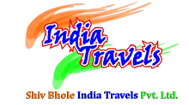
M/S Shiv Bhole India Travels
Add: 207, 2nd Floor, Suneja Tower-II, Janak Purl Dist. Center,
New Delhi 110058
Landline: 011-46569400/46552400
Handy: 95400-43400/95400-67400/95400-86400
Email Ids: sales@shivbholeindiatravels.com,
Visit us : www.shivbholeindiatravels.com,

